Constellation encoder

One of the significant problems in ADSL modem design is the inherent complexity of the
system. This project was aimed at developing a high level abstraction of the design of an
Constellation Encoder used ADSL transmitter. ITU-T Recommendation G.992.2 and G.992.1 standard for constellation encoder was implemented.
Description: For a given sub-channel, the encoder shall select an odd-integer point (X,Y) from the square-grid constellation based on the b bits {vb–1, vb–2, ..., v1, v0}. For convenience of description, these b bits are identified with an integer label whose binary representation is (vb–1, vb–2, ..., v1, v0). For example, for b = 2, the four constellation points are labelled 0, 1, 2, 3 corresponding to (v1,v0) = (0,0), (0,1), (1,0), (1,1), respectively.

NOTE – v0 is the first bit extracted from the buffer.

1.1 Even values of b
For even values of b, the integer values X and Y of the constellation point (X,Y) shall be determined from the b bits {vb–1, vb–2, ..., v1, v0} as follows. X and Y are the odd integers with twos-complement binary representations (vb–1, vb–3, ..., v1, 1) and (vb–2, vb–4, ..., v0, 1), respectively. The most significant bits (MSBs), vb–1 and vb–2, are the sign bits for X and Y, respectively. Figure 1.1 shows

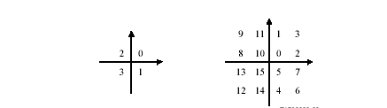
example constellations for b = 2 and b = 4.

Figure 1.1– Constellation labels for b = 2 and b = 4

The 4-bit constellation can be obtained from the 2-bit constellation by replacing each label n by a
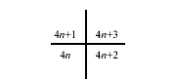
2 ⋅ 2 block of labels as shown in Figure 1.2.
Figure 1.2– Expansion of point n into the next larger square constellation

The same procedure can be used to construct the larger even-bit constellations recursively. The
constellations obtained for even values of b are square in shape.
1.2 Odd values of b, b = 3
Figure 1.3 shows the constellation for the case b = 3.

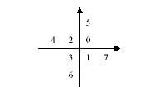
Figure 1.4– Constellation labels for b = 3

1.3 Odd values of b, b > 3
If b is odd and greater than three, the two MSBs of X and the 2 MSBs of Y are determined by the
five MSBs of the b bits. Let c = (b + 1)/2, then X and Y have the twos-complement binary
representations (Xc, XC–1, vb−4, vb−6, ..., v3, v1, 1) and (Yc, YC–1, vb–5, vb–7, vb–9, ..., v2, v0, 1), where
Xc and Yc are the sign bits of X and Y respectively. The relationship between Xc, XC−1, Yc, YC−1
and vb–1, vb−2, ..., vb–5 is shown in Table 1.

Table 1– Determining the top 2 bits of X and Y

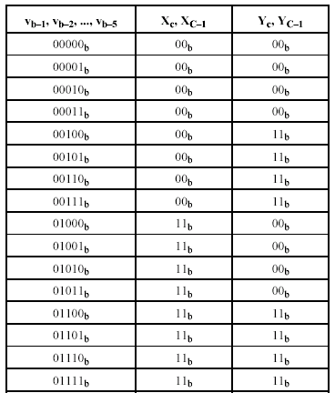

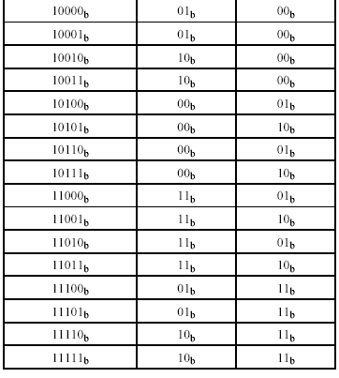

Figure 1.4 shows the constellation for the case b = 5.

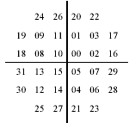

Figure 1.4– Constellation labels for b = 5

The 7-bit constellation shall be obtained from the 5-bit constellation by replacing each label n by the 2 ⋅ 2 block of labels. Again, the same procedure shall be used to construct the larger odd-bit constellations recursively.

The encoder takes the data bit stream and encodes it into N QAM constellation points. This encoding is done according to the bit loading table which defines the number of bits carried by each tone. Clearly high SNR (Signal to Noise Ratio) carriers can carry more bits than low SNR carriers so the bit loading table reflects the variation of the SNR over frequency. The bit loading table is calculated during start-up according to the actual measured SNR to allow optimal use of channel capacity. Loading is limited by the ADSL standard to 2-15 bits per tone. When we want to serve the customer with a specific bit rate, we allocate the bits to the carriers in such a way that the sum of all the bits on all carriers matches the desired rate, and the probability of error on each carrier is about the same. When we want to give each customer the maximal available bit rate, we allocate to each carrier the maximum number of bits that we can transmit without errors, based on the measured SNR of that carrier. This latter mode is usually referred as the rate-adaptive mode. This way a customer living close to the exchange will have a high SNR and high data rate, whereas a customer living far from the exchange will suffer from more line attenuation and less bits shall be allocated on each of the carriers.

